|  |
| --- |
| A+Computer Science METHODS- Break Free Lab Value-100 |

Lab Goal: This lab was designed to teach you more about using loops and recursive statements to navigate the island and free his fellow jeroos.

Lab Description: Using recursion, as well as if or while statements, create a method that will allow the jeroo to pick all flowers and find all nets destroy them with flowers. Create another method that will have the jeroo plant flowers around the perimeter of the island. Once this is done, have the other jeroos with run east until they reach the flowers.

Start Screen: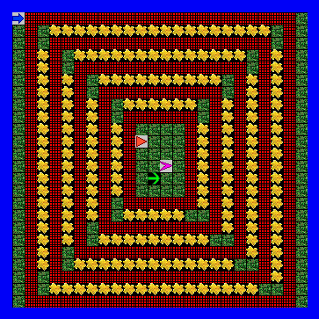



End Screen: